**Capstone Project - The Battle of Neighborhoods**

1. **Introduction**

Taipei is the capital and a special municipality of Taiwan (officially the Republic of China, ROC). It is also a city whose allure lies in its blend of Chinese culture with a curious fusion of Japanese, Southeast Asian and American influences. Whenever visitors visit to a new city they are looking for the restaurants during their stay. Thus, in this presentation, I will explore restaurants of Taipei based on Foursquare data. Try to provide support to new visitors helping them to explore the places visiting Taipei could explore.

1. **Data Requirements**

* Taipei Administrative Divisions  
  <https://en.wikipedia.org/wiki/Taipei>
* Restaurants in each districts of Taipei  
  Use Foursquare APIs to get restaurants(section=food) in each district.

The first step was to get Taipei districts table from Wikipedia and transformed it to pandas dataframe. Using geocoder class of Geopy client to get coordinates of those districts. Then, I used Foursquare API to get the top 100 restaurants of all districts within a radius of 5000 meters. As the result, totally got 1160 restaurants.

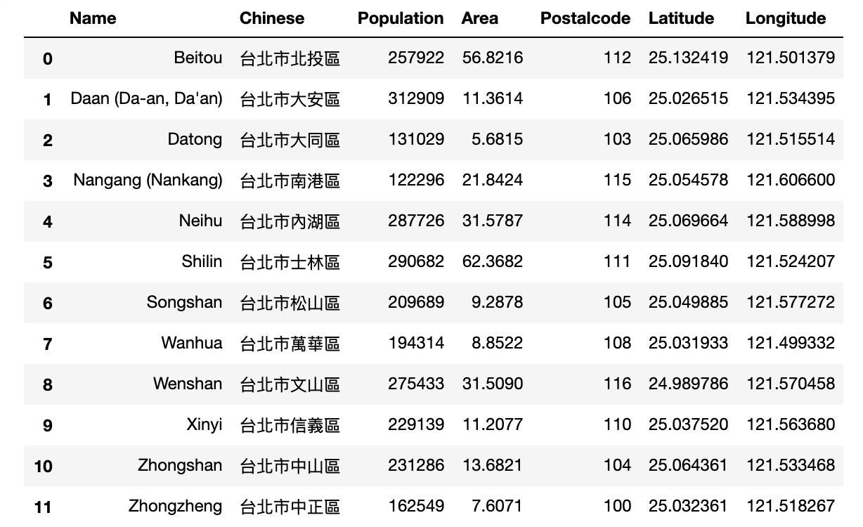

List of 12 Taipei Districts

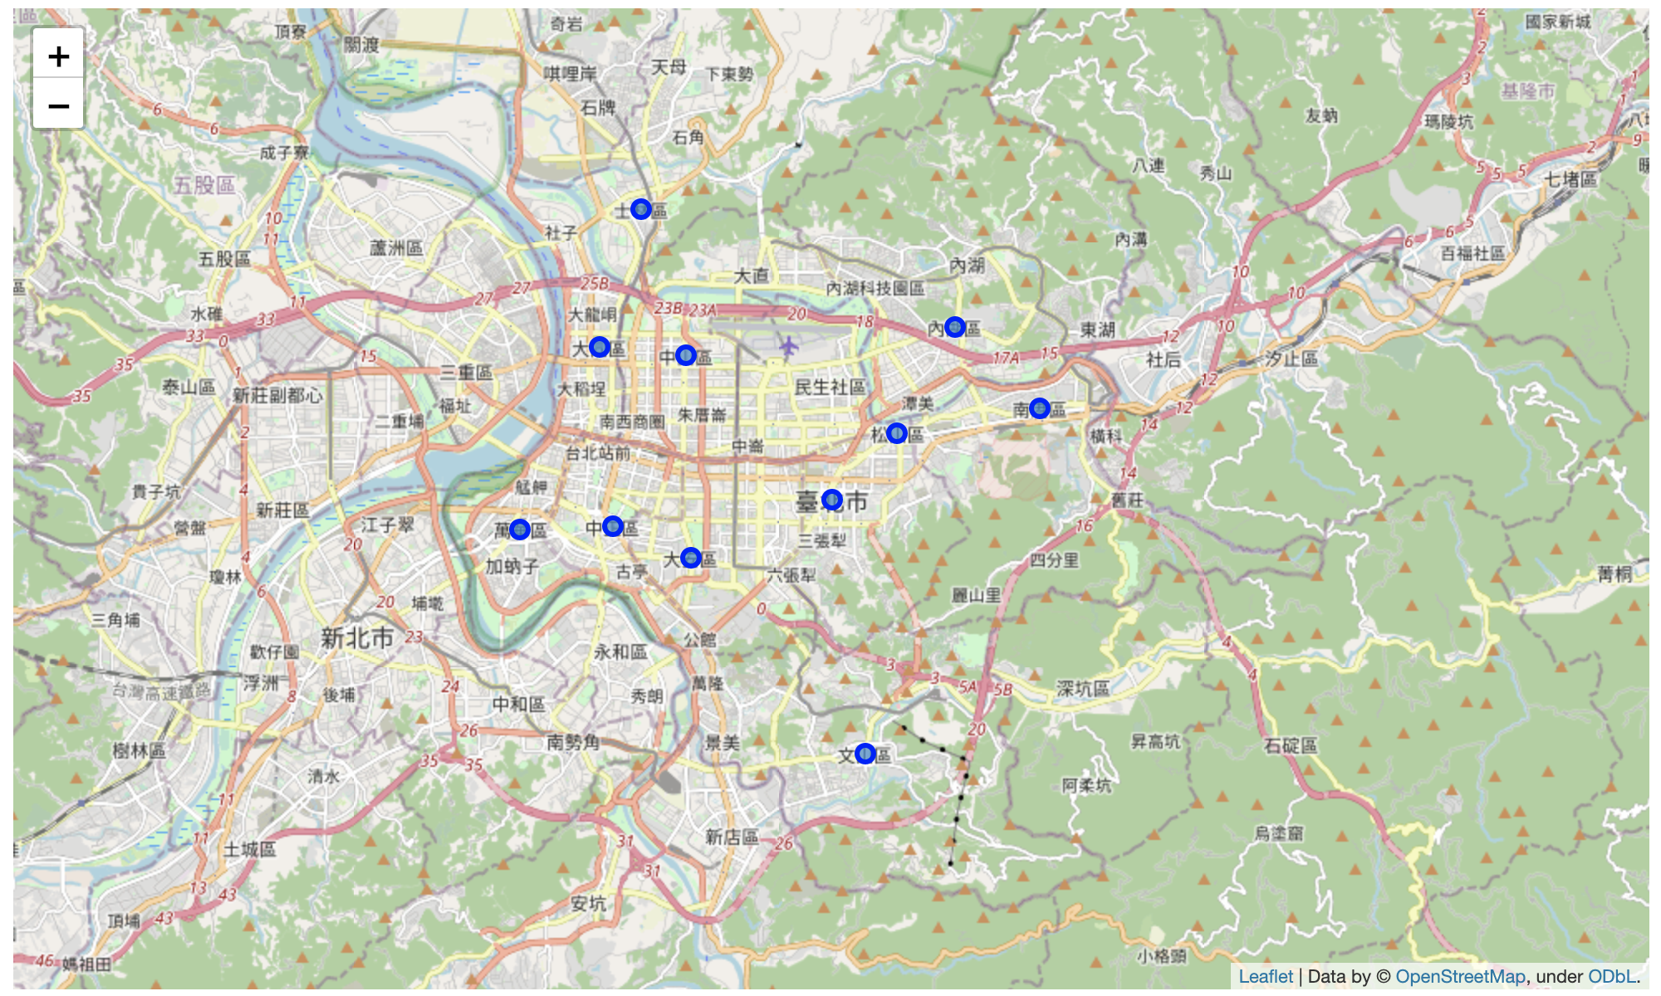

Visualize geographic details of 12 Taipei Districts

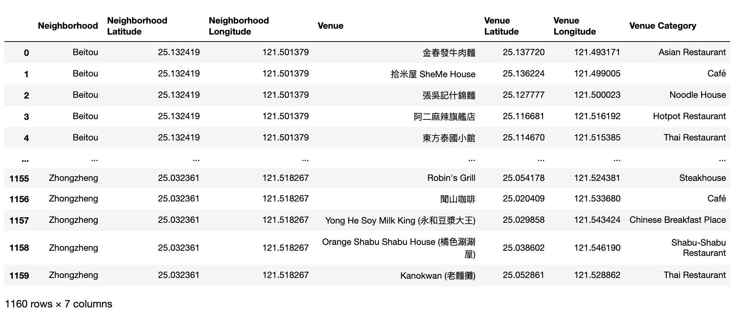

Sample of restaurants got from Foursquare API

1. **Methodology**

As the first step, I retrieved the data from Foursquare API by extracting venue information from 12 districts of Taipei, upto a distance of 5 Km. After that, I got 1160 restaurants with different categories.

I analyzed the data based on the category of each restaurants. I identified the top category types and places where many restaurants are located so that any visitor can go to one place and enjoy the option to choose amongst many restaurant options. After that, I clustered the districts based on the available information of each restaurants. This will allow us to clearly identify which districts can be recommended and with what characteristics.

* + 1. **Exploratory Data Analysis**

**Category**

We can find out 68 unique categories of restaurants in Taipei. Chinese Restaurants are the top one, the second one is Taiwanese Restaurants, and the third one is Noodle House as we can see in the plot below:

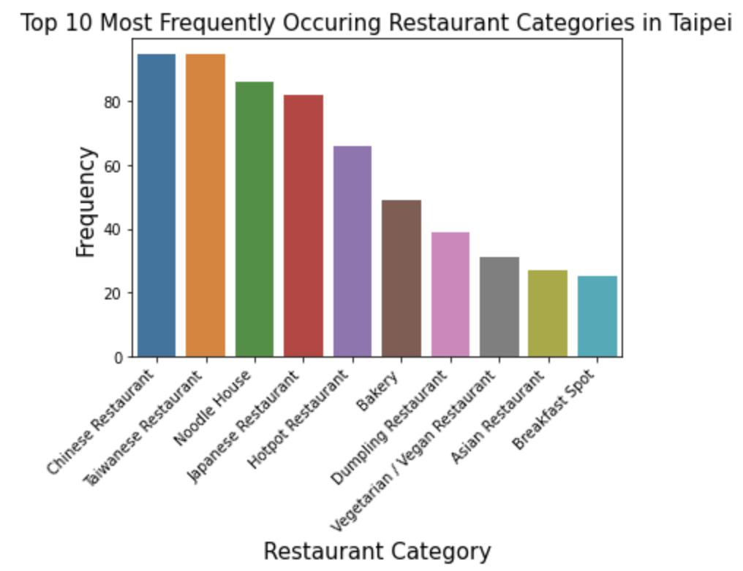

As the result, when visitor visit Taipei definitely need to try the Chinese Restaurants and Taiwanese Restaurants.

**Category vs. Location**

We can find out each district has about 30 different categories. Songshan, Shillin, and Zhongshan are the top 3 districts with many different categories.

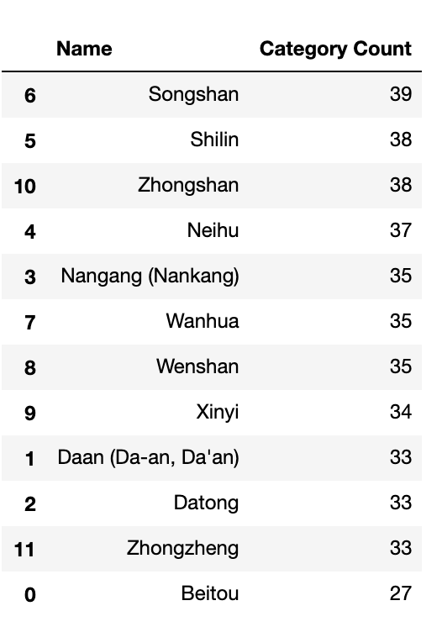 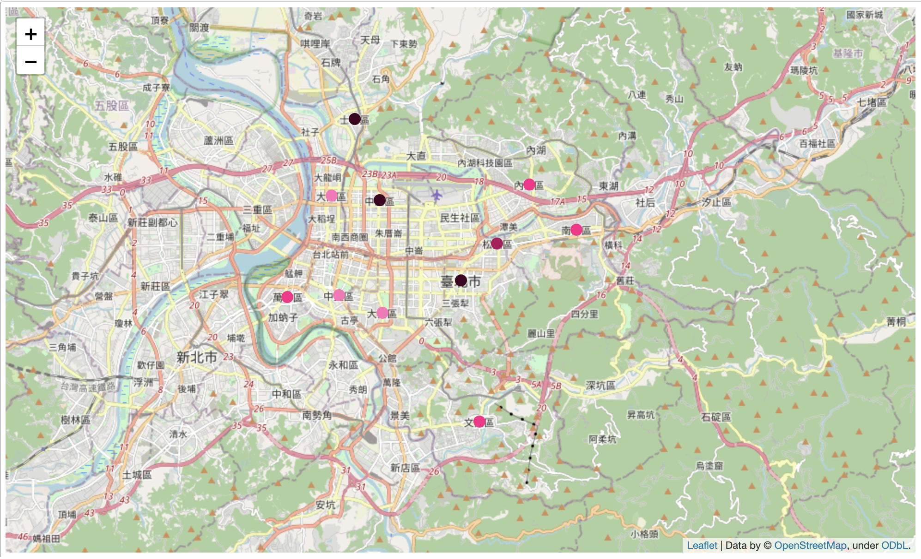

Output each neighborhood along with the top 5 most common categories:

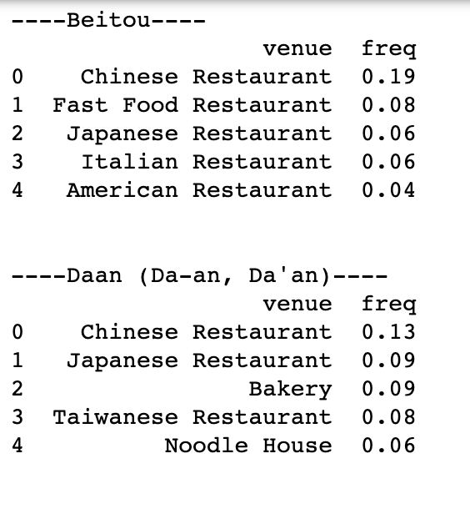 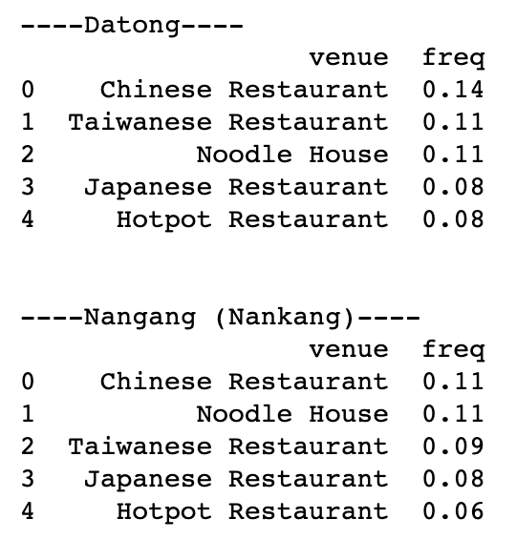 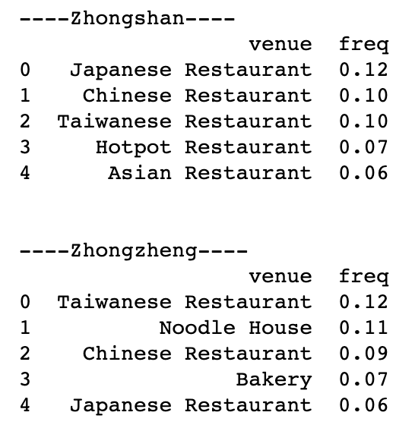

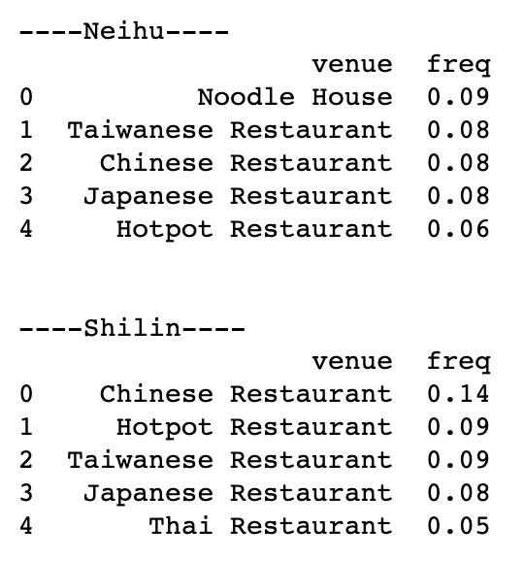 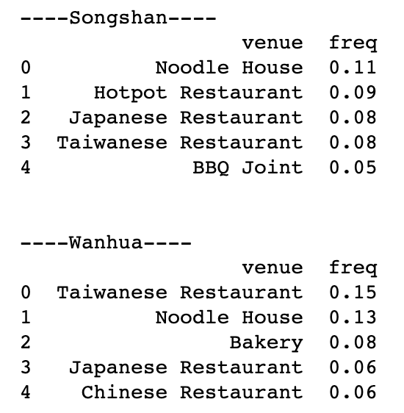 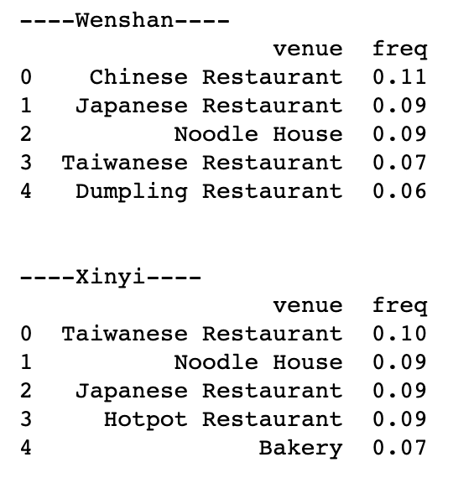

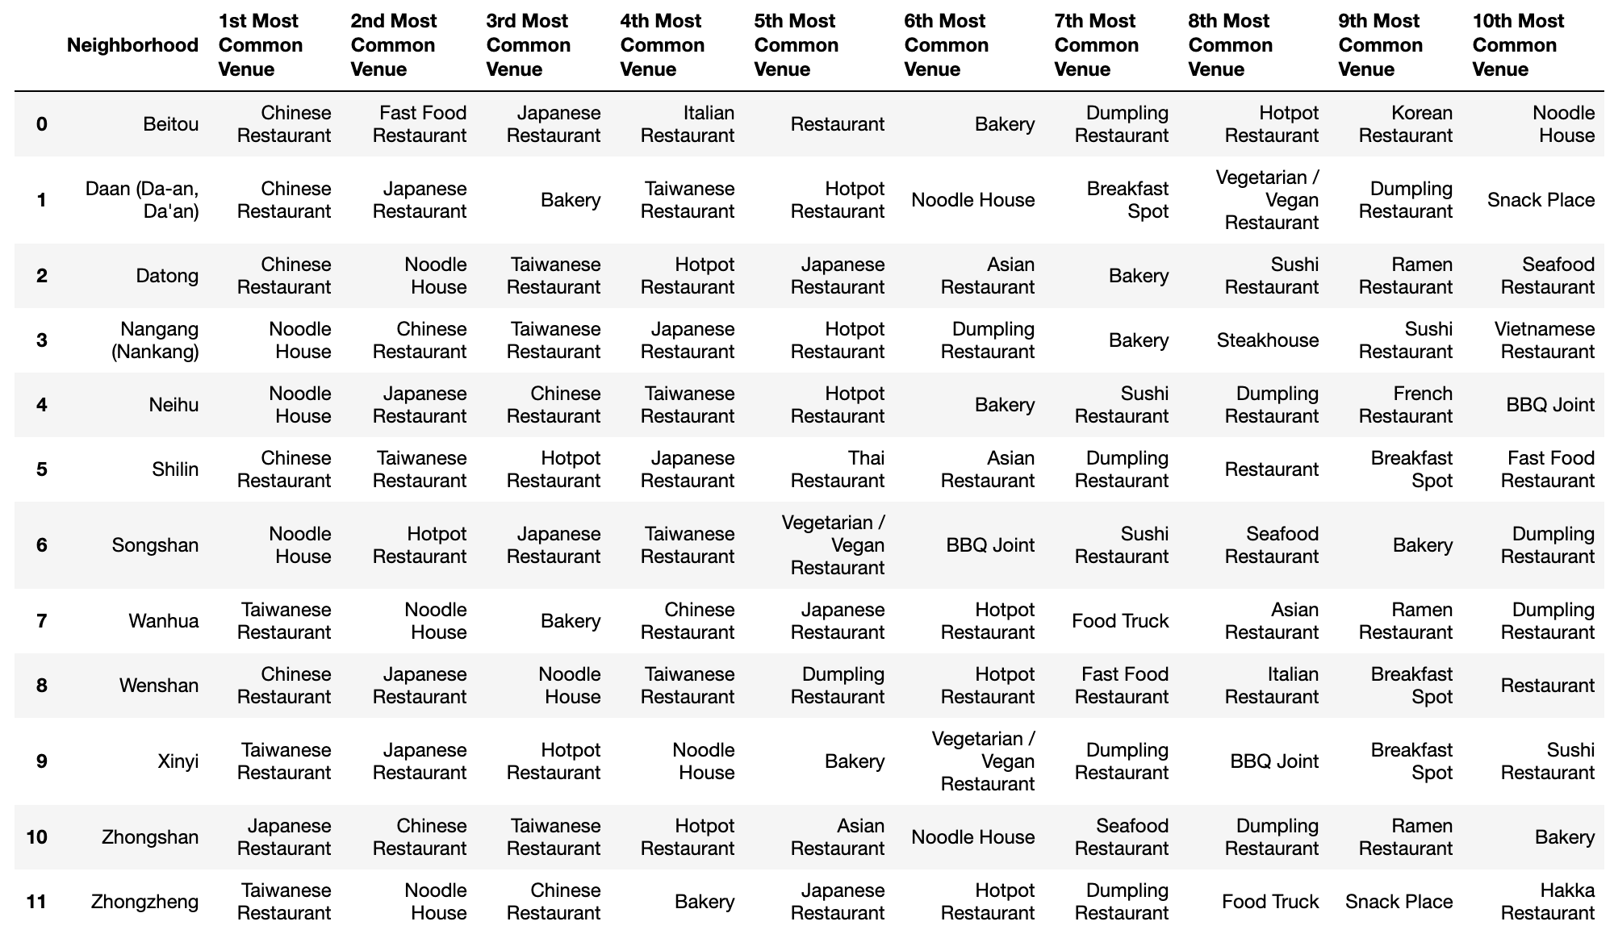

* + 1. **Clustering Analysis**

Finally, I tried to cluster these 12 districts based on the venue categories and use K-Means clustering. So, based on the similarities of venue categories, these 12 districts will be clustered into 5 groups. The 5 clusters in a map as below:

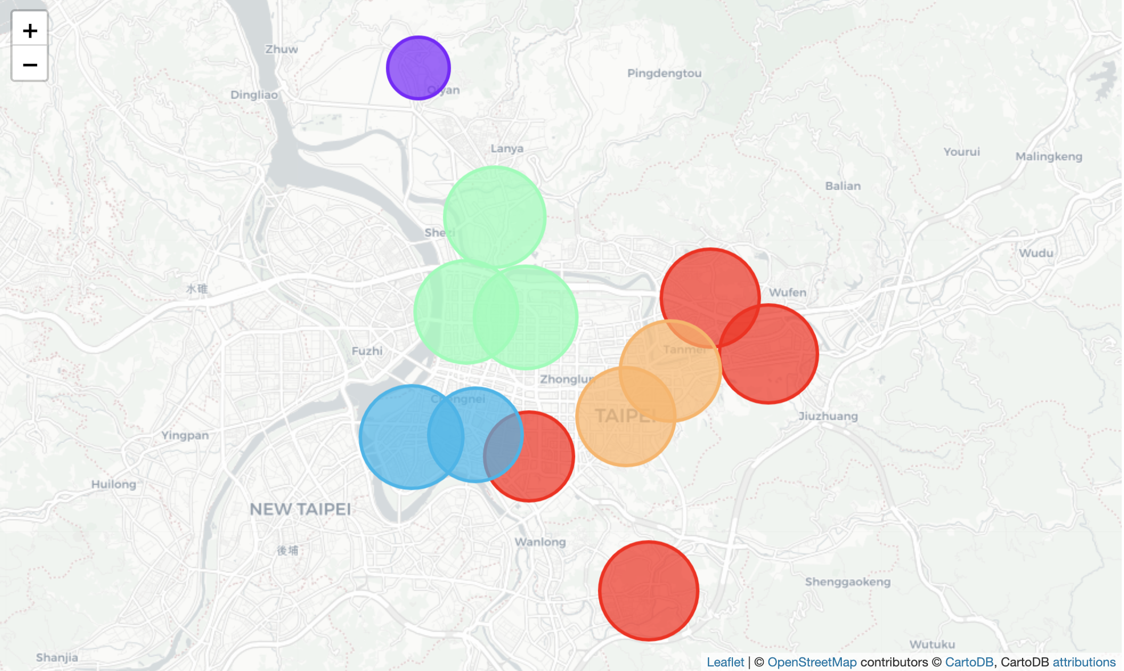

1. **Results & Discussion**

I found out some interesting insights which might be useful to visitors. Let’s summarize the findings:

* Chinese restaurants are the most popular restaurants in the 12 districts.
* Songshan has maximum number categories of restaurants.
* The districts in the central of the city has more different categories of restaurant than in the border of the city.
* The clustering was based on the category of restaurants on each district, so districts in the same cluster indicate that each of those districts presents a similar experience to the visitor in terms of category of food. Visitor can plan to visit different clusters to experience different food.

In the analysis, I ignored many other factors like prices of restaurants, rating of restaurant, distance of the restaurants from stations, and so on. Hence, this analysis only helps visitors to get anoverview of restaurants distribution by categories. This results also could potentially vary if we use some other clustering techniques like DBSCAN.

1. **Conclusion**

The purpose of this project was to explore the districts of Taipei that can help visitor visiting Taipei to fit the most their needs. I have made to parse web content to get districts of Taipei, use Foursquare API to explore restaurants in each districts and saw the results of segmentation of districts.